**Assignment Details**

**Given:** In the following given table, the columns of *Age, Income, Student, Credit_Rating* denote the attribute/features; and the column *Buys_Computer* denote decision/class label.

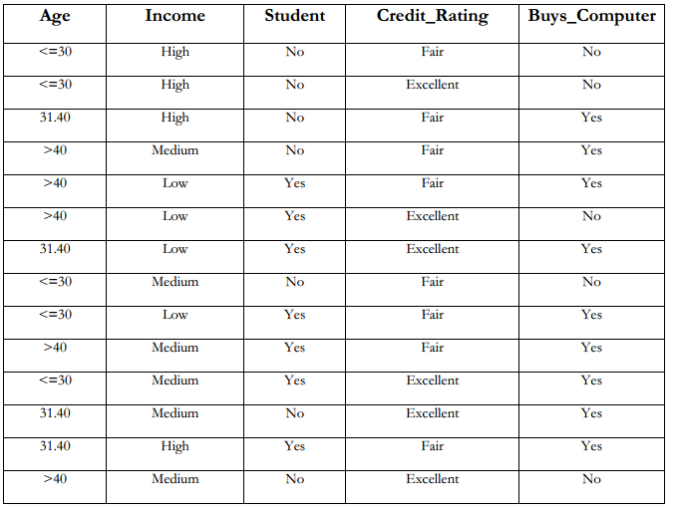

**Task:** Calculate Gini-Index, Information-Gain and Gain-ratio for all the attributes, and for each case, find out which attribute should be considered as the root node.